E-commerce Microservices Project Overview

This project is a 10-component microservices application, architected to support an e-commerce platform. Each microservice is developed using a different programming language, designed to handle a specific business function.
The solution adopts a hybrid DevOps architecture, combining managed AWS cloud services such as EKS, EC2, Route 53, and DynamoDB with self-hosted, open-source tools like Jenkins, SonarQube, Trivy, and Prometheus, deployed on EC2 instances. This hybrid model enables flexible infrastructure management and optimized tool control.
The project also embraces a hybrid toolchain and methodology by integrating DevSecOps practices using Trivy and OWASP Dependency-Check, automating infrastructure provisioning with Terraform, and implementing scheduled compliance scans through cron jobs and automated email reporting.
Finally, the monitoring and alerting are handled via real-time dashboards using Grafana and Prometheus, ensuring full visibility and operational oversight across the CI/CD pipeline and runtime environment.

- Source Code Structure:
  - All services are located in the SRC directory.
  - Each service contains its own Dockerfile, describing how to build and run the container.
  - Kubernetes manifest files (Deployment and Service YAML) are stored in the release directory.

Here are the step by step workflow:
----------------------
Infrastructure Setup

IAM & AWS CLI
Create an IAM user with the required permissions for managing services like EKS, EC2, and S3.
Install:

- AWS CLI
- Python3 and boto3 (for scripting and AWS integration)
- EKSCTL
- KUBECTL

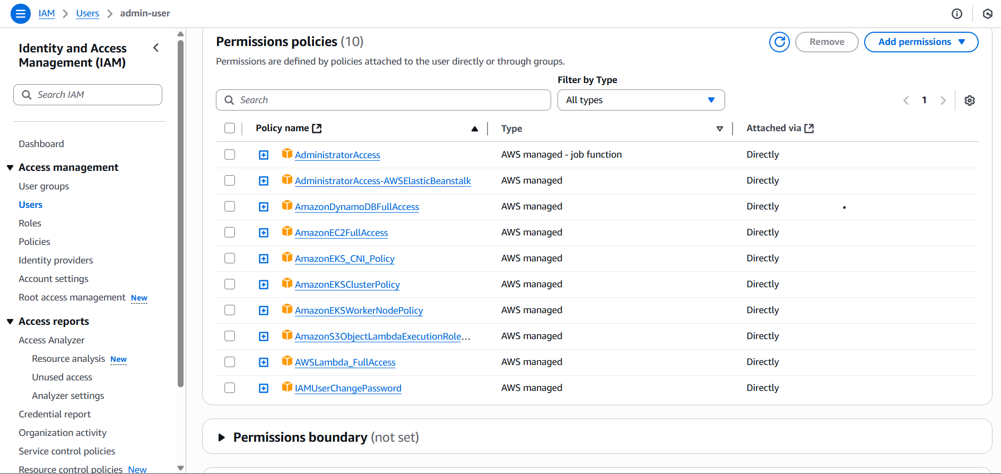

----------------------
EKS Cluster Setup

- Create EKS Cluster using eksctl.
- Configure OIDC for IAM roles for service accounts (IRSA).
- Update Security Groups to allow required inbound rules.
- Create Service Account, IAM Role, and Role Binding for access to AWS resources.

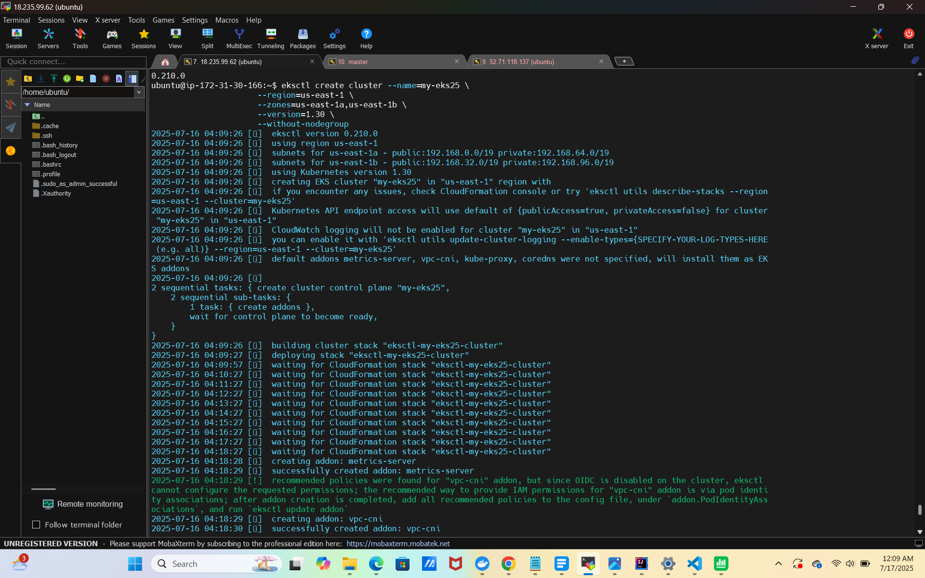
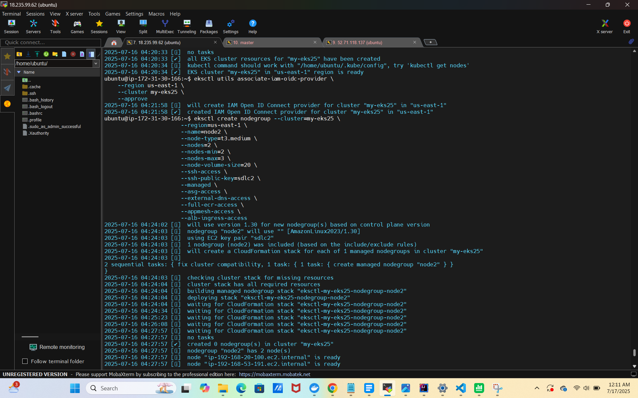
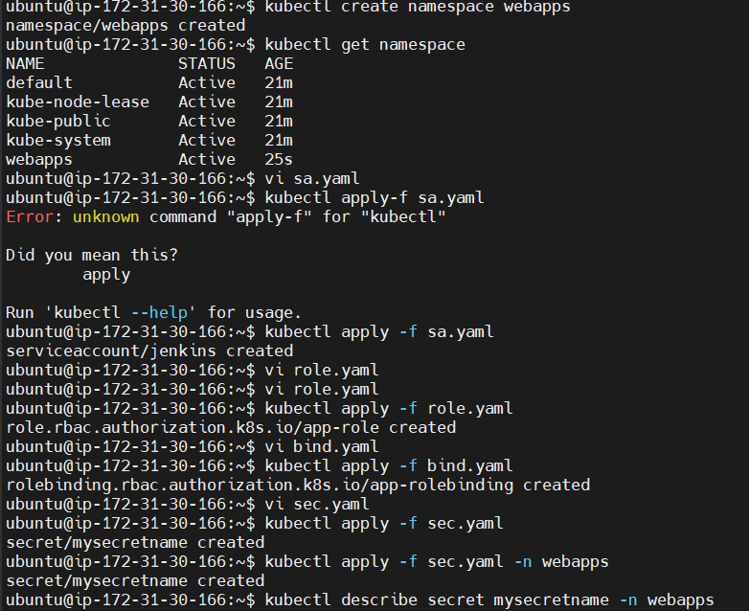
----------------------
Jenkins Server Configuration (Master)

- Launch an EC2 instance (Ubuntu).
- Install and configure:
- Jenkins
- Docker

- Setup plugins:
- SonarQube Scanner
- Docker Pipeline
- Kubernetes
- Email Extension
- OWASP Dependency-Check
- CloudBees Docker BUild
----------------------
Jenkins Pipeline Overview

- Git Checkout: Clones the main branch from the GitHub repository.
- SonarQube Analysis: Performs static code analysis for code quality.
- Quality Gate: Waits for SonarQube's approval (quality gate pass).
- Docker Build & Push: For each microservice:
Navigates into service directory.
Builds Docker image.
Pushes image to Docker Hub.
Removes local image to save space.
- Kubernetes Deployment: Uses withKubeConfig to authenticate and deploy manifests to EKS (my-eks8) in the webapps namespace.
Restarts frontend service and lists pods/services.
- Post Actions: Email Notification
Sends an HTML email with build status and link to console logs.
Attaches pipeline-report.html (security scan report).

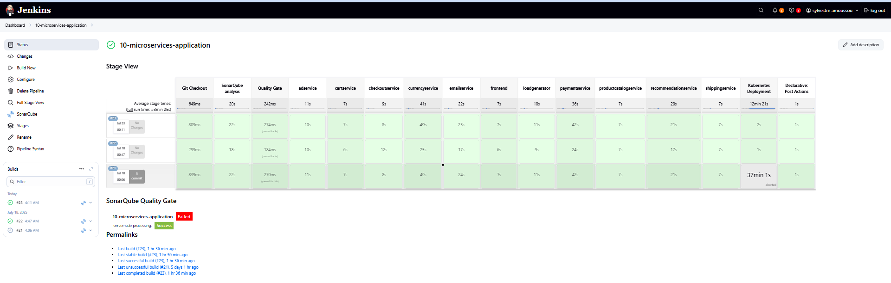

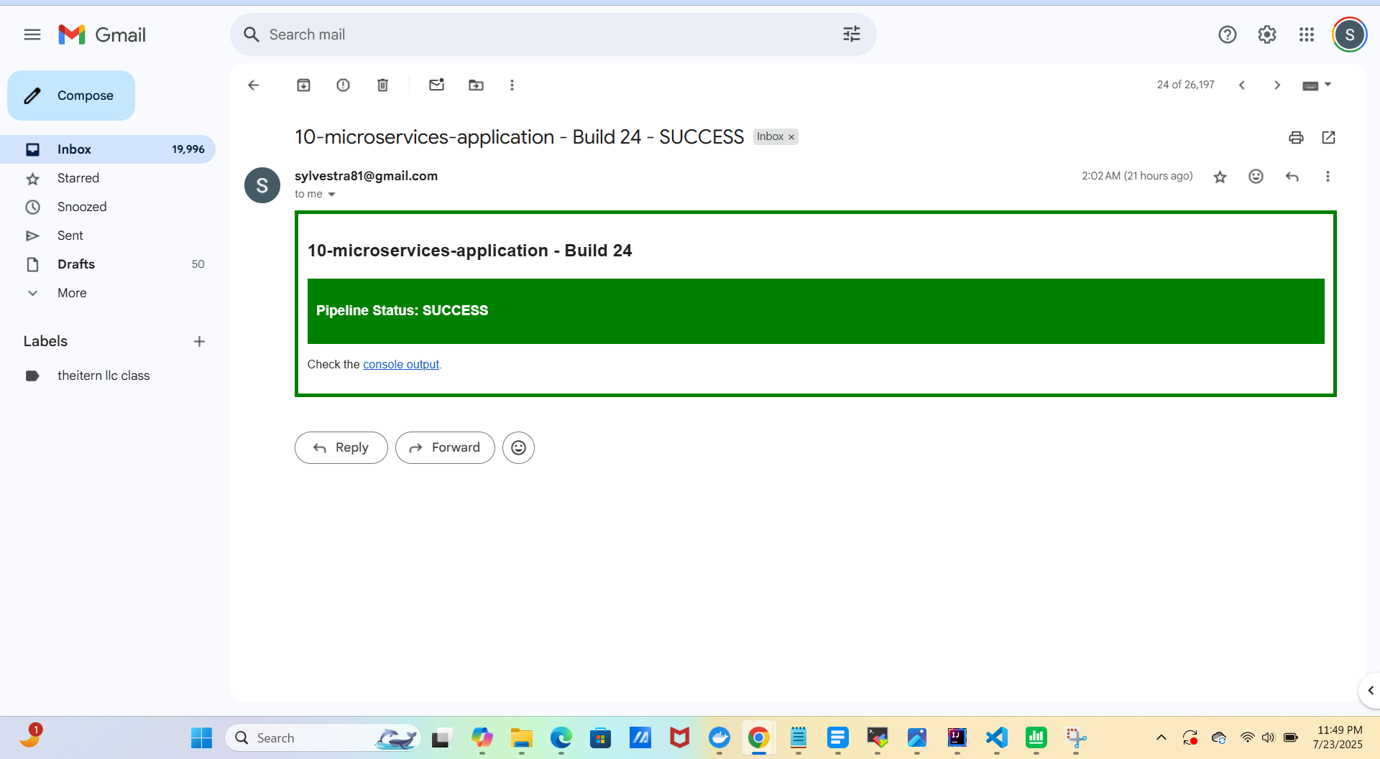

----------------------
Cluster Deployment Summary

2 EC2-backed worker nodes, both in Ready state, running the same Kubernetes version.
- All microservices pods are healthy.
- Internal communication uses ClusterIP.
- Frontend is exposed via:
NodePort for internal access.
AWS ELB (ALB) for public access.
Public Access URL:
http://aca0ca7e8923946dc8a4ea48c54a0c30-1575239514.us-east-1.elb.amazonaws.com

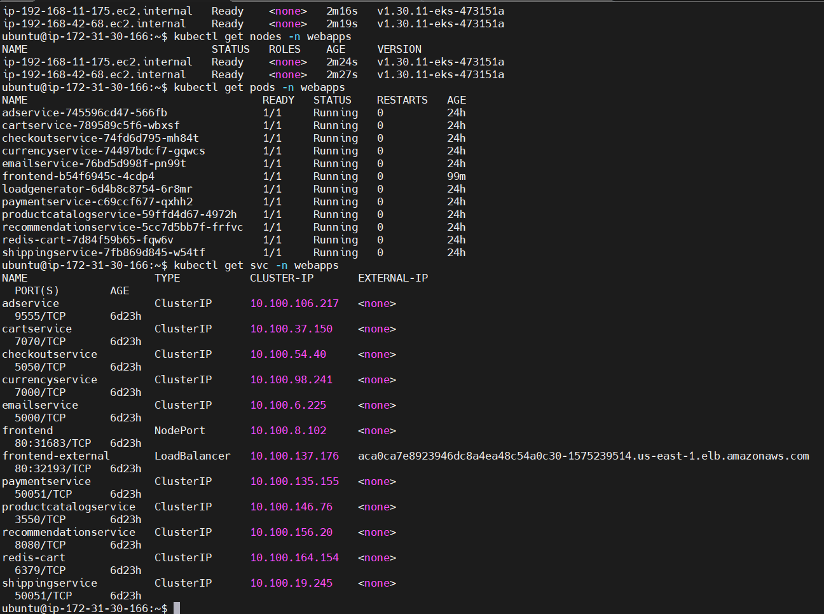
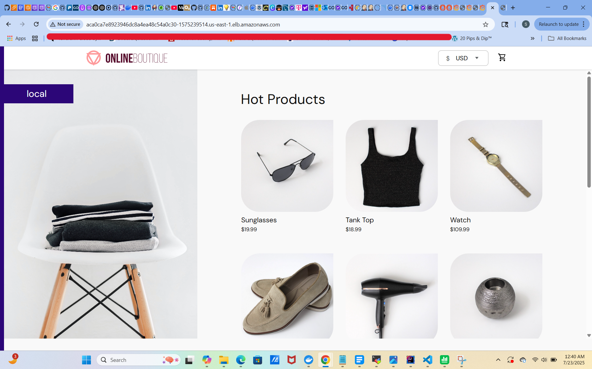

----------------------
Security & Testing Slave Node Setup

To enhance CI/CD security and automate vulnerability scans, we configure a dedicated Jenkins slave node and integrate it with AWS DynamoDB to store security reports.

Here is the step by step workflow:

- Launch a slave EC2 instance:
  - Ubuntu / t2.medium / 20GB
  - Attach Elastic IP
  - Install Jenkins agent and Docker
- Connect slave to master node (via SSH).
- Install:
  - OWASP Dependency-Check (on both master and slave)
  - Trivy (on both master and slave)
  - Jenkins Plugins: View Job Filters, OWASP DC

DynamoDB Table Creation Using Terraform and it integration with Jenkins Pipeline:
We use Terraform to create a DynamoDB table where vulnerability scan reports will be stored
- A Python script (using boto3) is added to Jenkins to parse Trivy and OWASP DC reports and upload the data into DynamoDB.

Cron Job Setup: Configure automated job execution every Friday at 11:30 PM for scanning and testing.

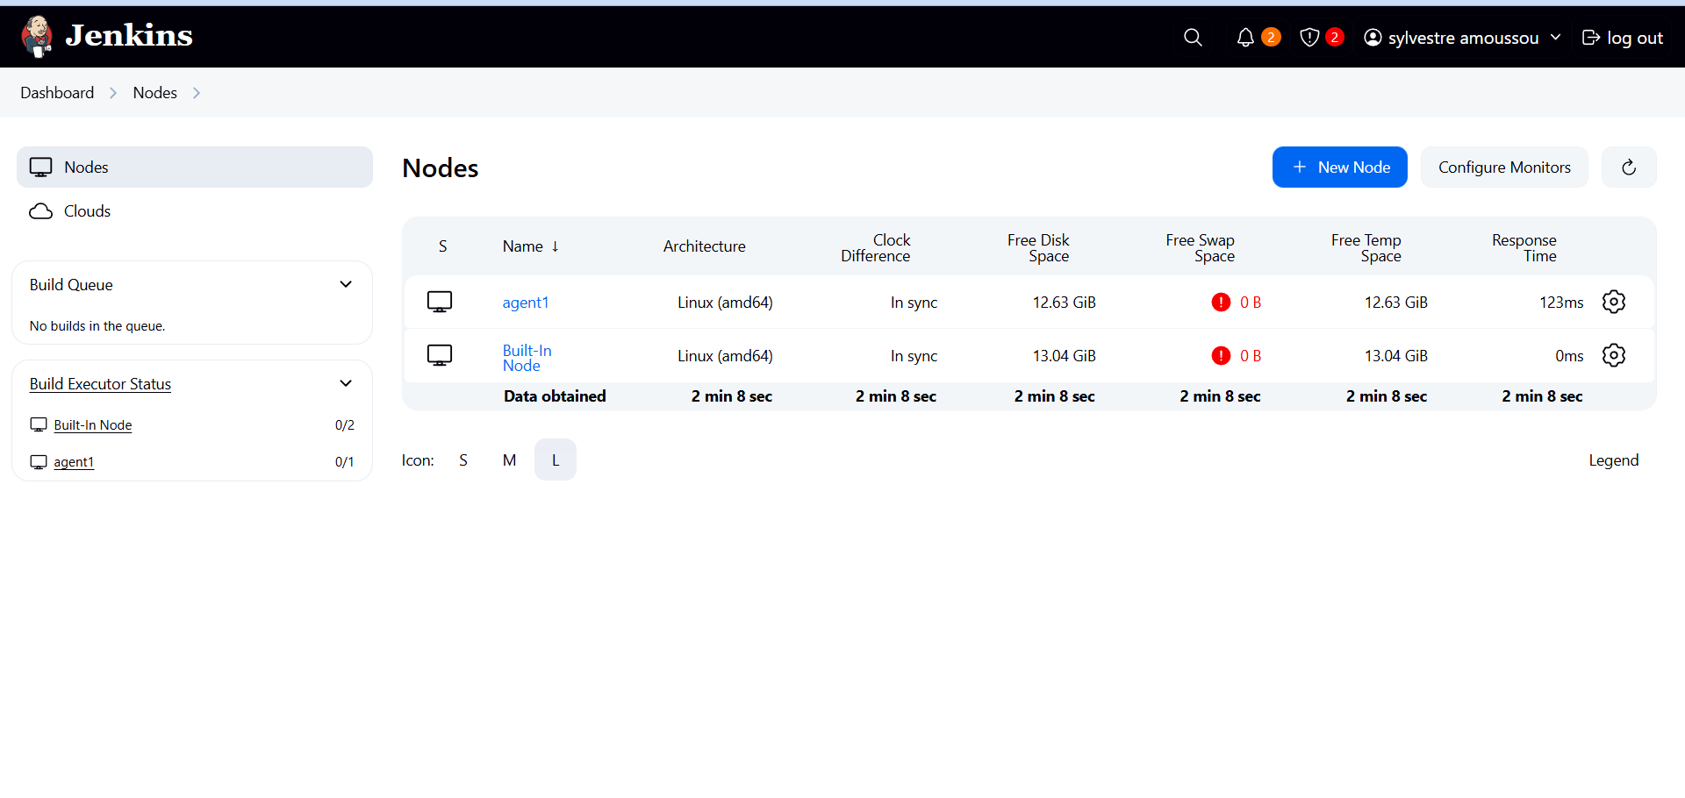
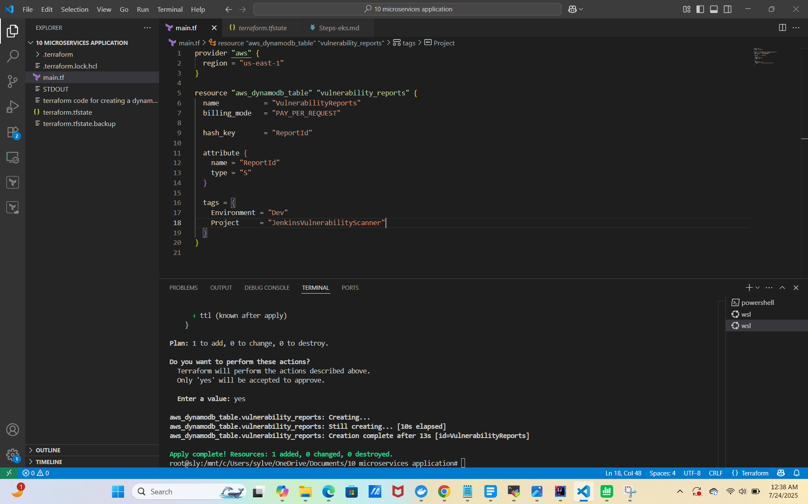
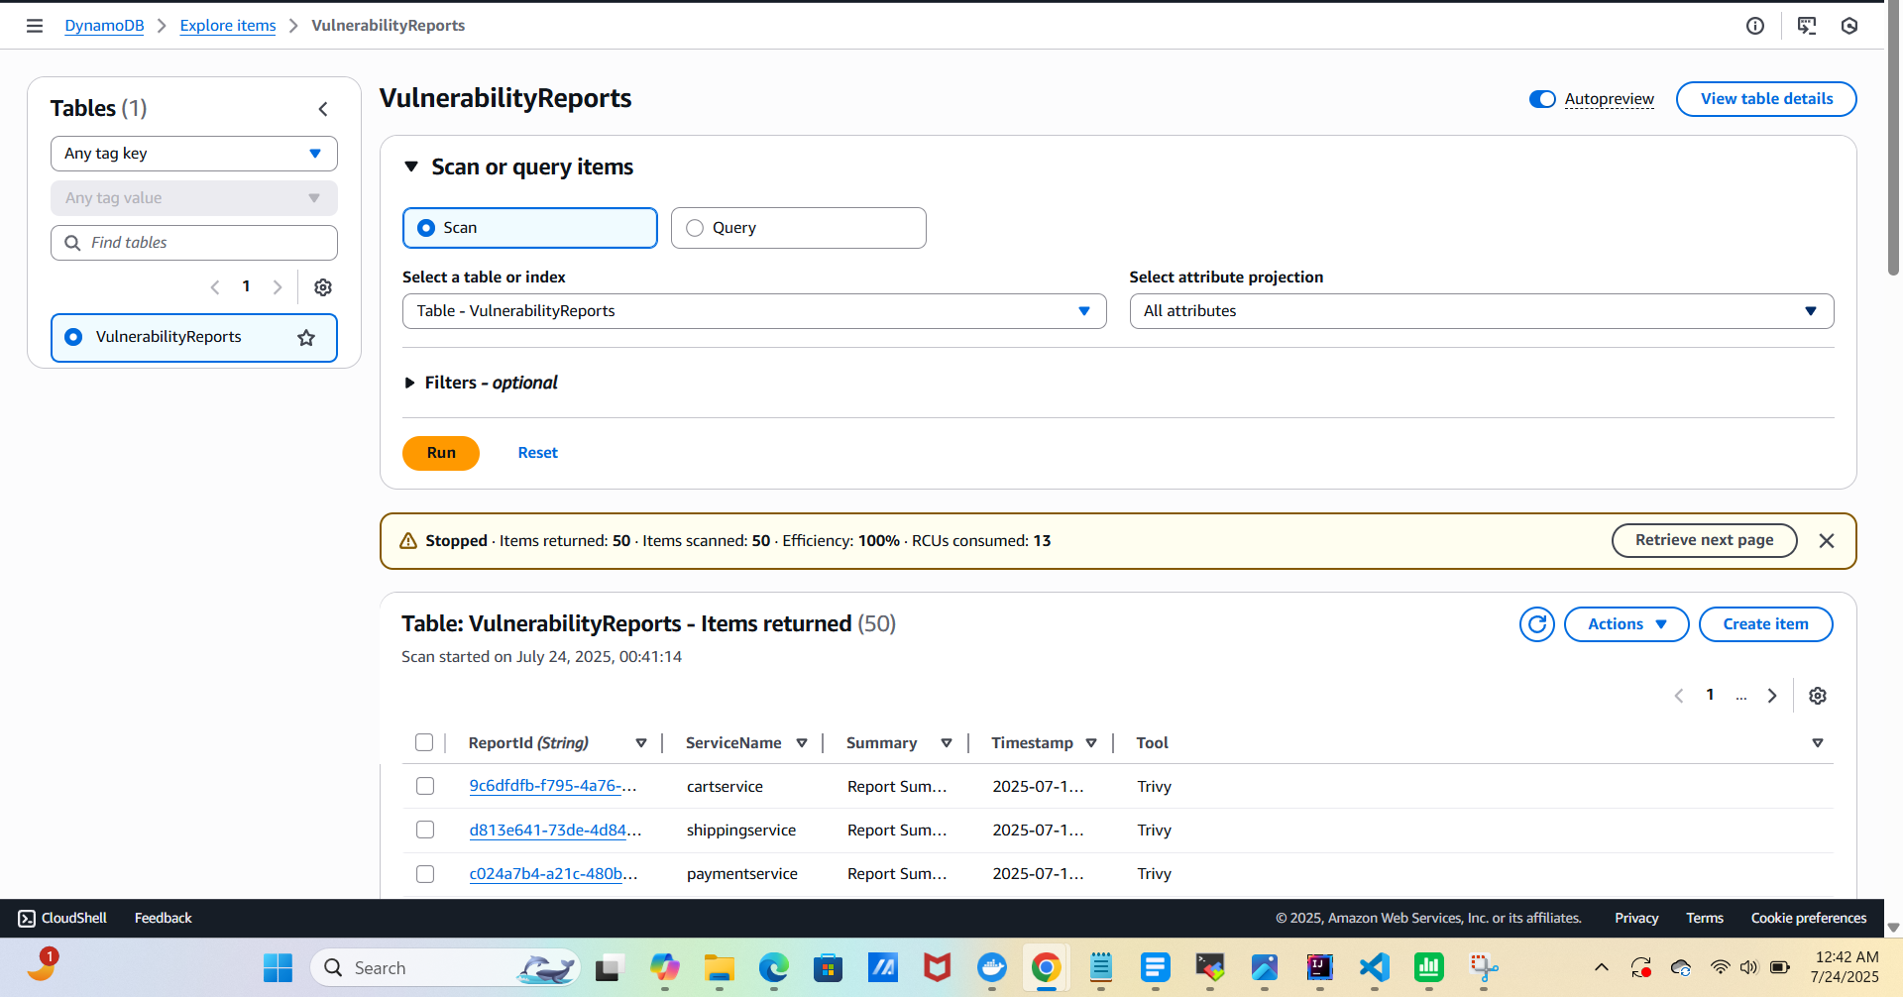
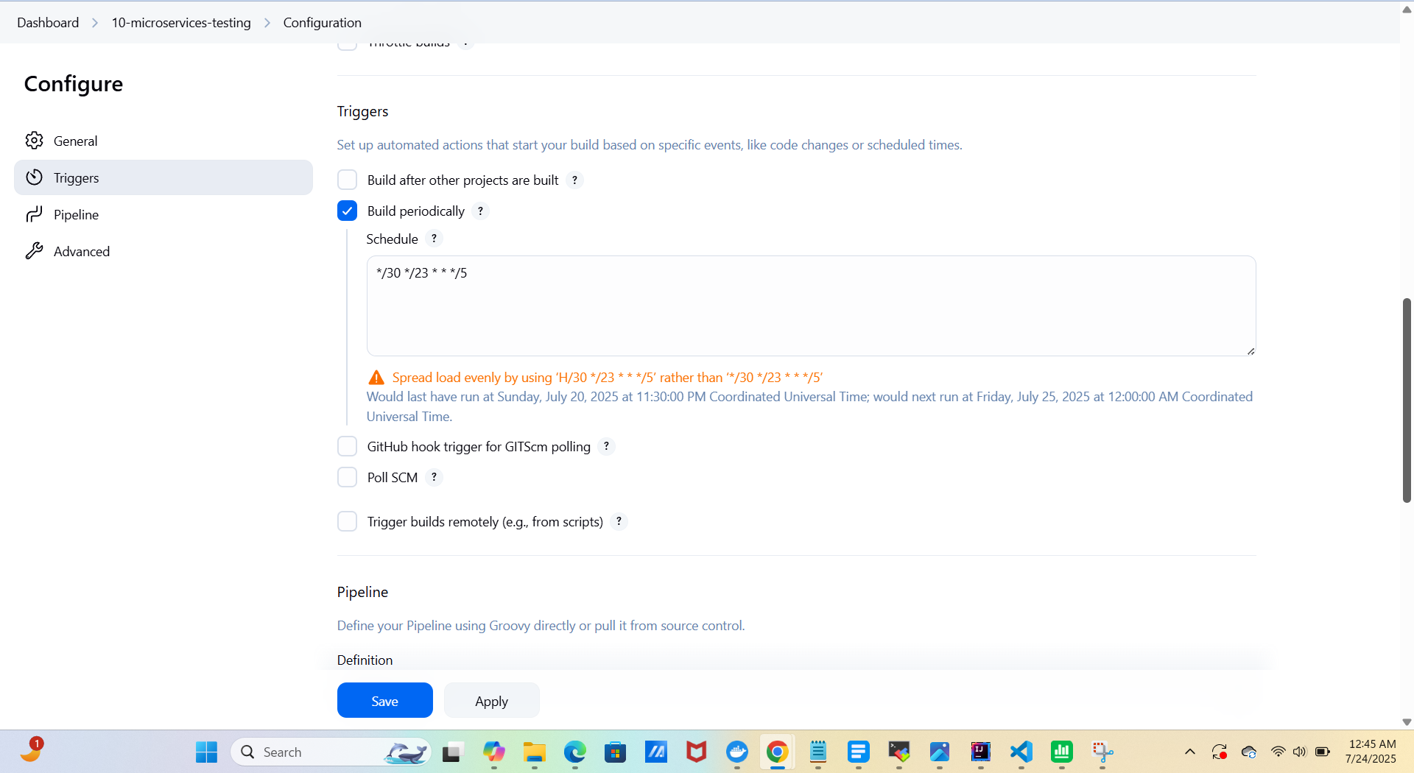
----------------------
Slave Node Pipeline Stages

- Git Checkout: Clones the main branch from GitHub.
- File System Scan with OWASP DC: Scans source files for vulnerable dependencies.
- Docker Image Scan with Trivy and report to DynamoDB:
Scans each Docker image.
Generates an HTML report.
Uploads the report to DynamoDB using Python script.
Backs up data to S3 bucket.
- Email Notification: Sends the trivy-image-report.html via email after execution.

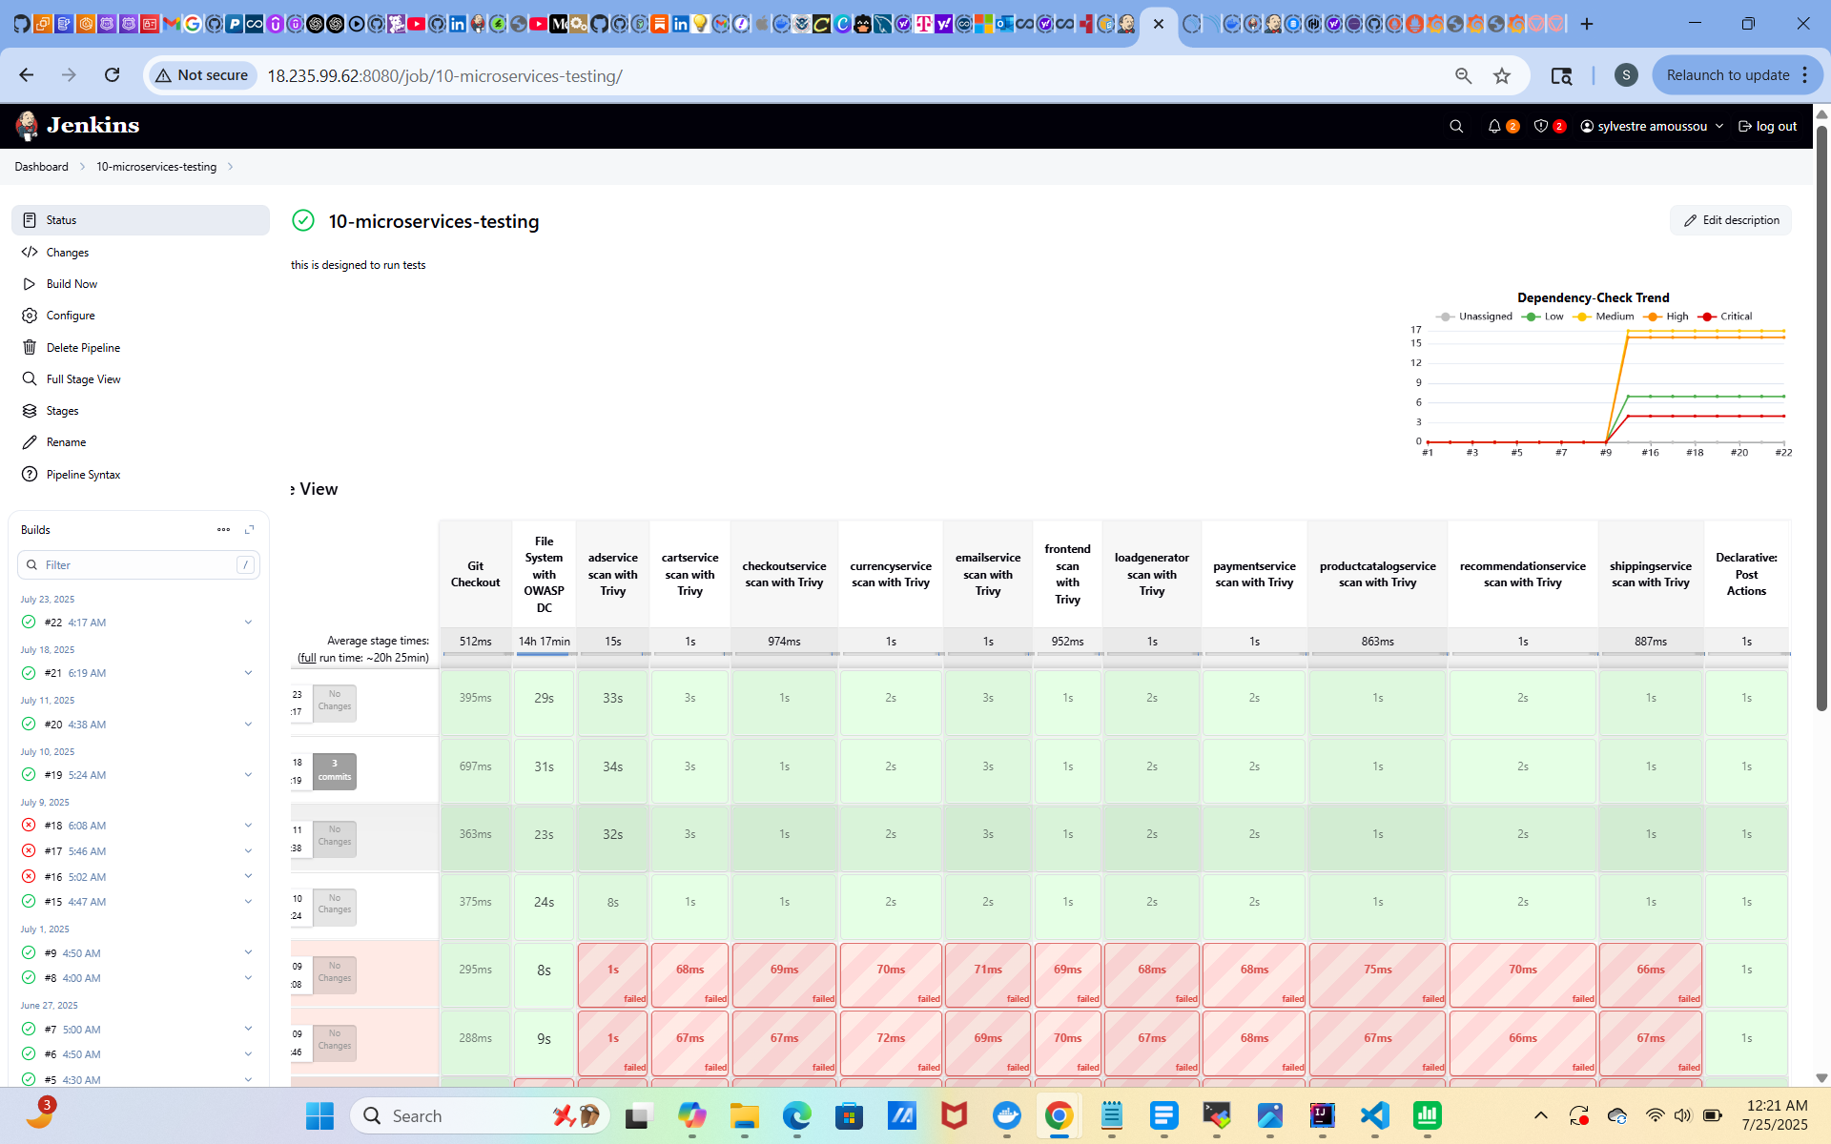
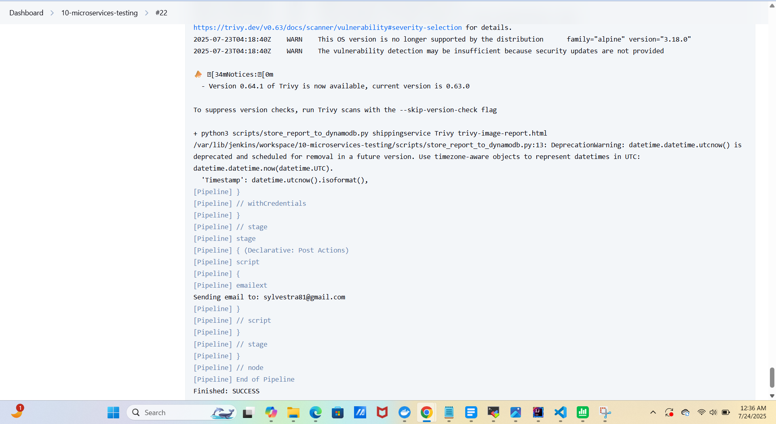
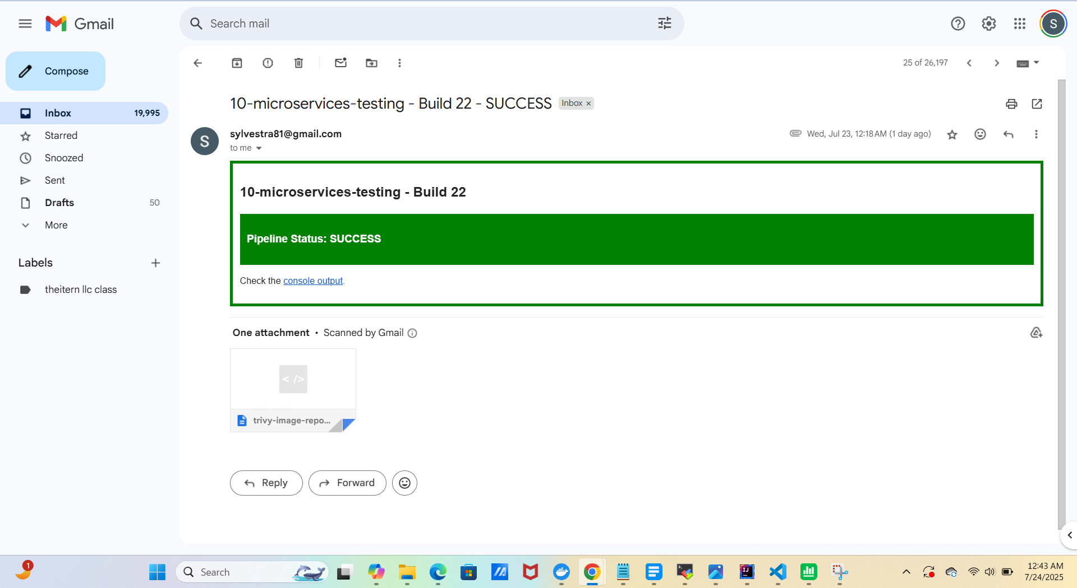

----------------------
Monitoring (Master Node)

- Application-Level Monitoring

- Tools: Prometheus, Grafana, Blackbox Exporter
- Metrics:
  - HTTP/HTTPS endpoints
  - Application response and uptime

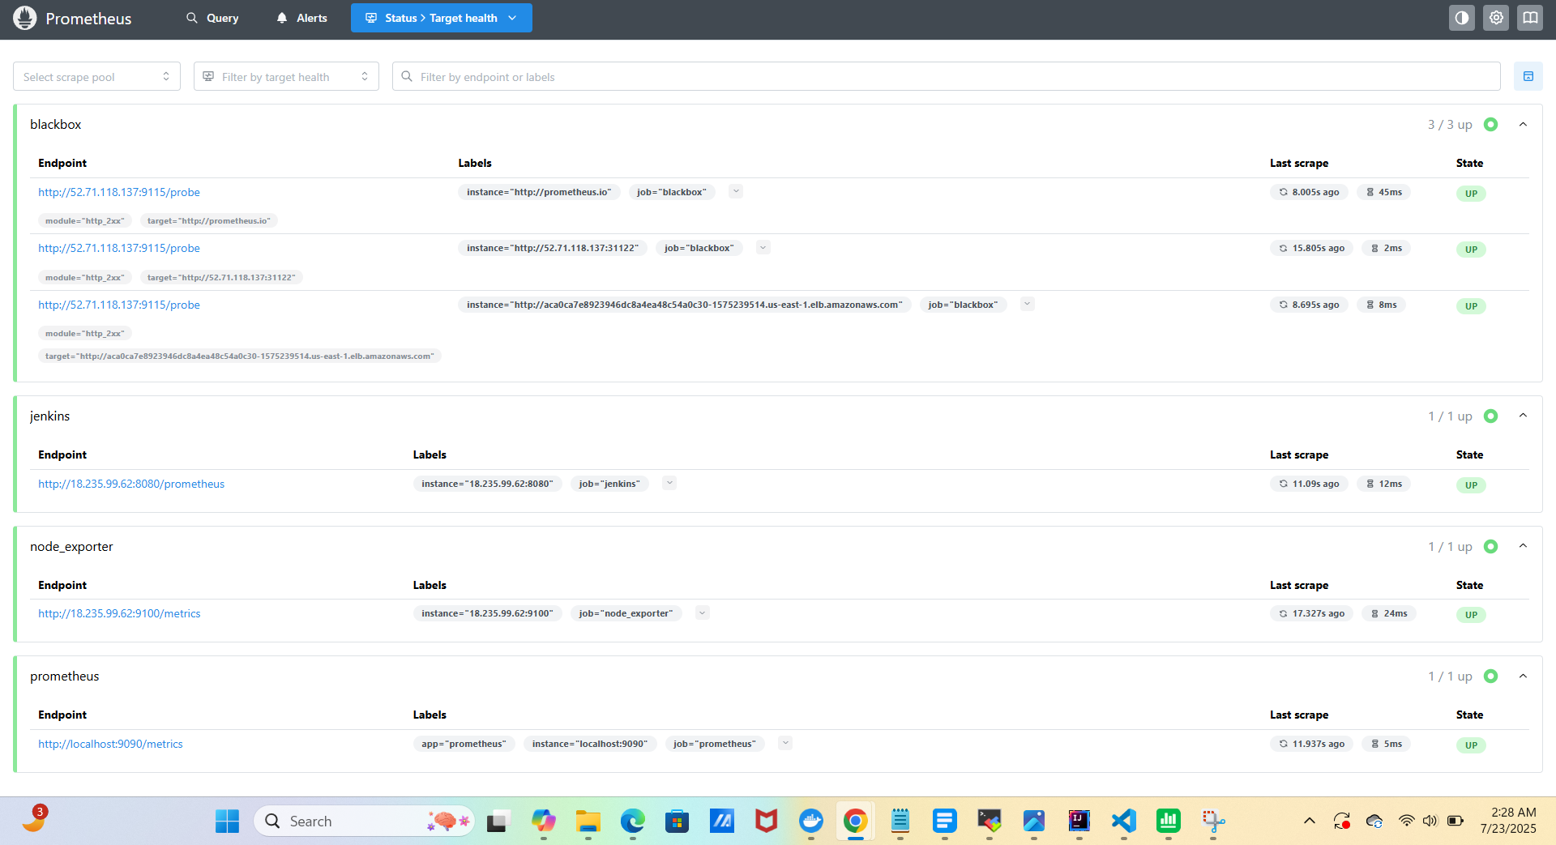
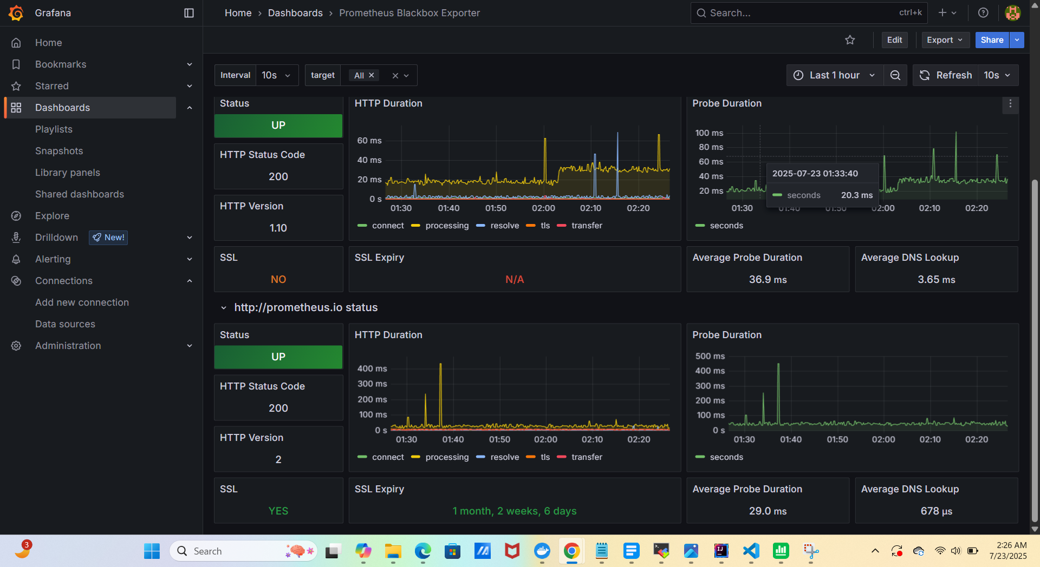

- System-Level Monitoring

- Tools: Node Exporter, Prometheus, Grafana
- Metrics: Jenkins CPU, memory, disk usage, Network traffic
Steps:
- Install and configure Node Exporter
- Add Node Exporter to Prometheus config
- Create Grafana dashboard for Jenkins

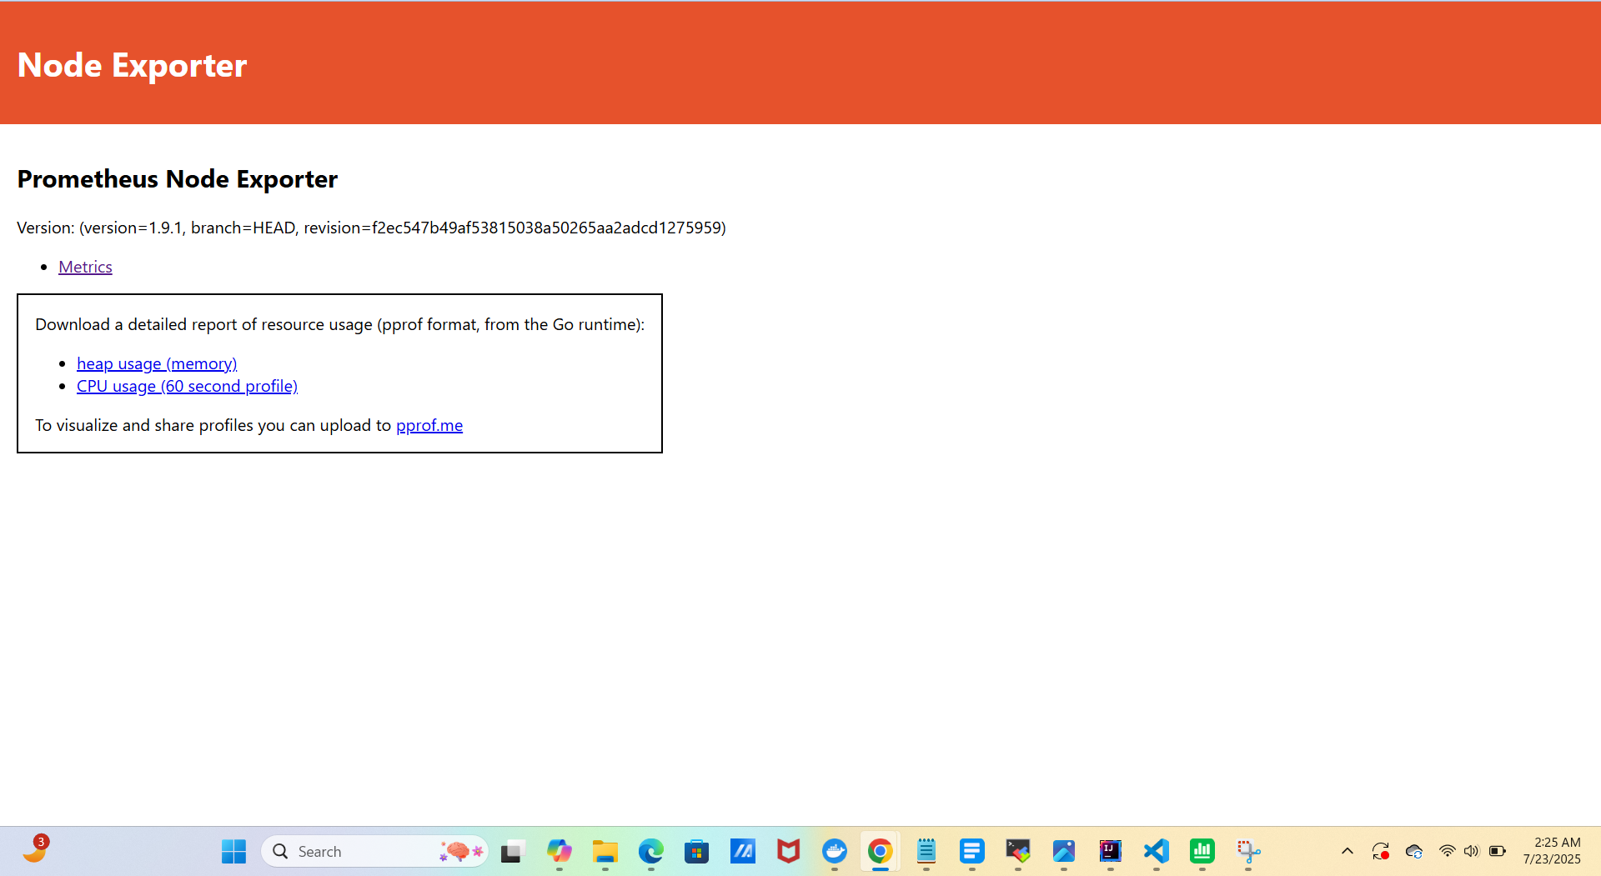
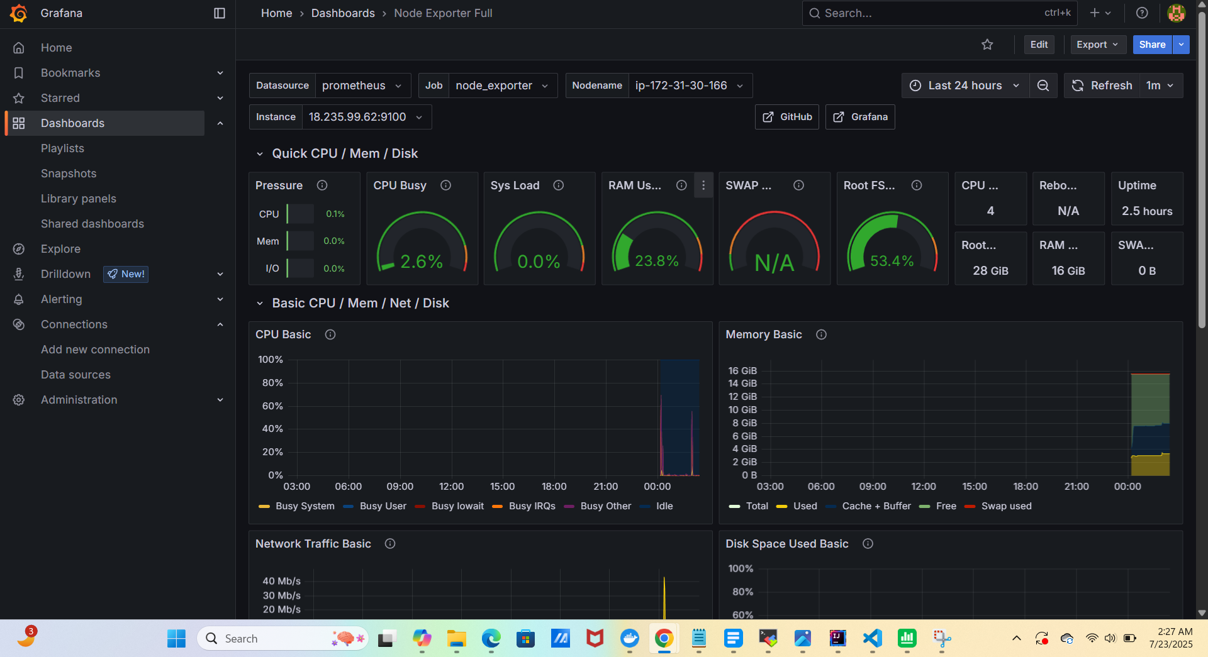

----------------------
DNS Setup with Route 53

- Register a domain (e.g., slyboutiques.click).
- Create a Hosted Zone in Route 53.
- Add a DNS (CNAME) record pointing to your ALB DNS name.
- Test the custom domain:
👉 http://www.slyboutiques.click

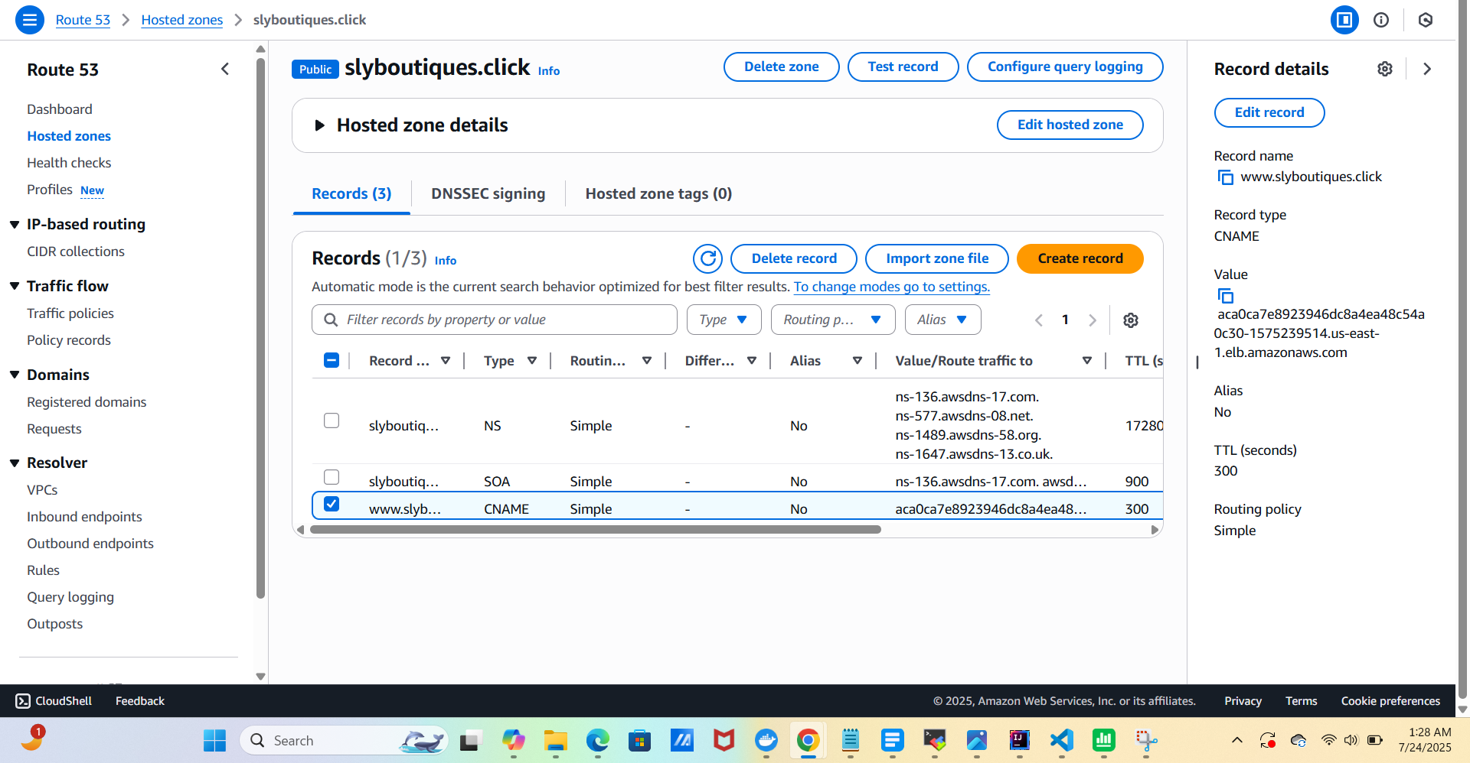

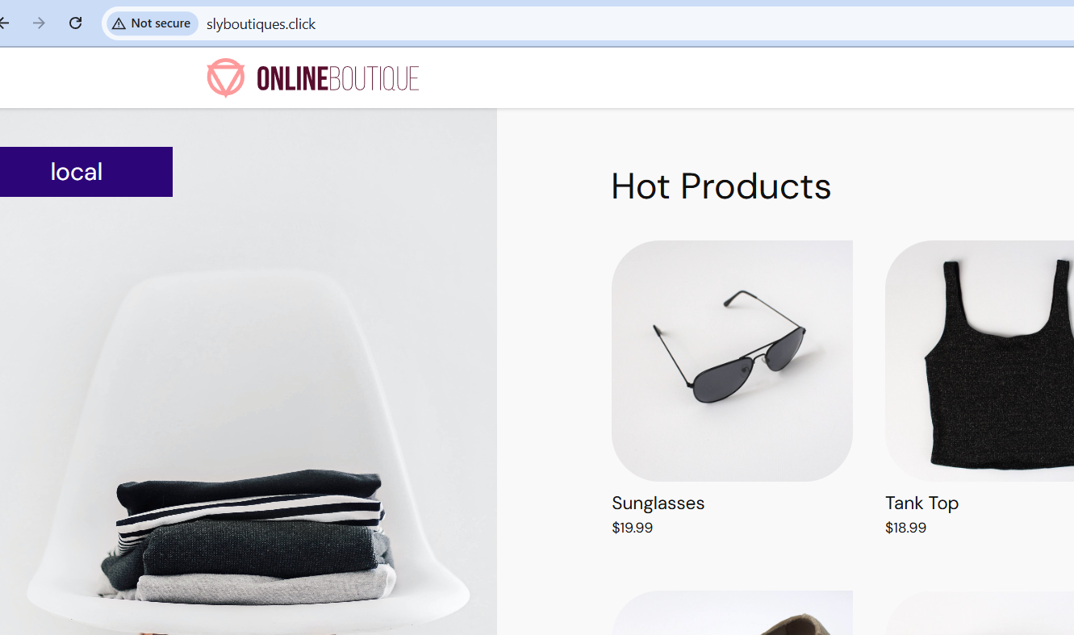

----------------------
Conclusion

Throughout this project, we have implemented modern DevOps practices, automation tools, and cloud-native technologies to deliver a secure, scalable, and observable microservices-based application.

- ✅ Modular microservices architecture improves scalability and accelerates development.
- ✅ Security-first CI/CD pipeline with scheduled vulnerability scans and automated reporting.
- ✅ Robust monitoring and alerting provide full observability into system and application health.
- ✅ Production-ready deployment pipeline with real-time notifications and Route 53–based custom domain support.

